Part B
Q5
- D
- D
- D
- D
- C
- C
- C
- C
- A
- A
- A
- A
- B
- B
- B

Q6

Diagram the LR(1) states for the given grammar , and construct the LR(1) parsing table. Indicate clearly any conflicts.
0. S → G $
1. G → P
2. G → PG
3. P → id : R
4. R →
5. R → id R

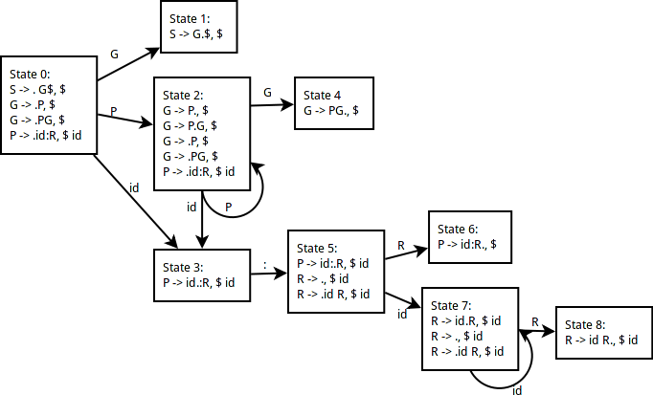
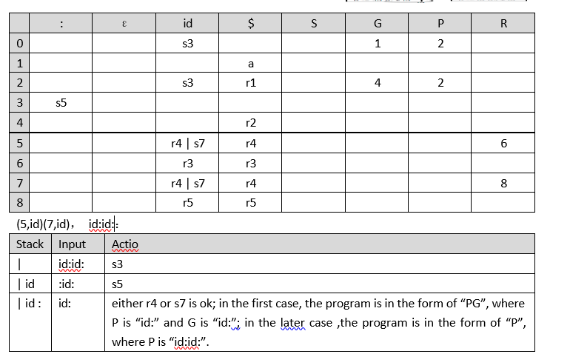

(c ) Not LR(1) DUE TO SHIFT REDUCE CONFLICTS AT STATE 5 AND 7.

